The Roman Emperor as Egyptian Pharaoh
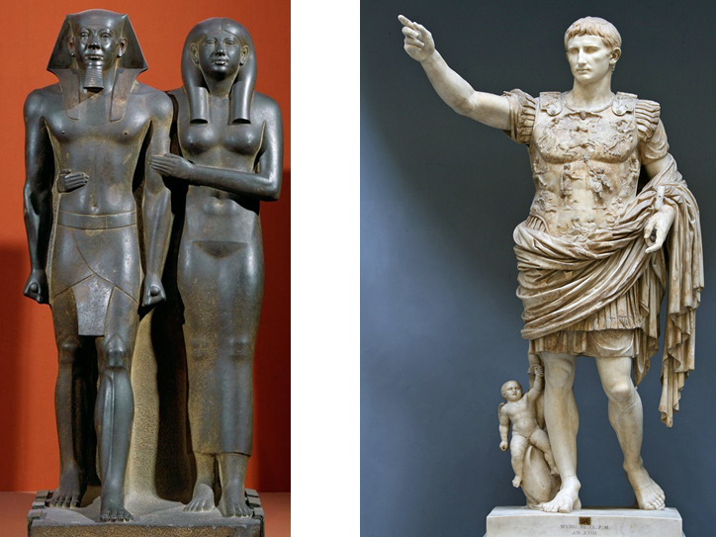
IMPERATOR CAESAR DIVI FILIVS AVGVSTVS

The historical background:

Egypt became a Roman province following the victory of Augustus at the battle of Actium in 31 BC. Queen Cleopatra was defeated, ending the Ptolemaic dynasty that had ruled Egypt since the death of Alexander the Great. To legitimise their rule of Egypt, Augustus and the subsequent Roman emperors drew on ancient Egyptian traditions surrounding divine kingship, and had themselves portrayed as Pharaohs in reliefs, sculpture and texts.

What does this workshop cover?

This one hour workshop is designed as an introduction to imperial power in the province of Egypt, focussing on how art and texts were used to portray the Roman emperor as a divine Pharaoh according to ancient Egyptian tradition. It is suitable for secondary students of Classical Civilisation or Ancient History, but requires no prior knowledge of Egyptology or Classics.

What will students learn?

The workshop will introduce students to Egyptian reliefs and sculpture depicting the emperor as Pharaoh, and some texts dealing with the topic of the emperor’s relationship with the Egyptian religion. The students will compare the images and texts, in order to learn to identify similarities and differences between the two mediums. The workshop will increase awareness of how the Roman imperial power was experienced in Egypt, a province with a well-established divine monarchy and ancient traditions surrounding kingship.

About Maiken Mosleth King:

Maiken has previously completed a BA and MA in Egyptology at the University of Liverpool, studying the ancient Egyptian language, literature and religion in-depth. She is now working towards a PhD at the University of Bristol, researching social identity in the Greek-speaking community of Terenouthis in Roman Egypt, with particular focus on gender, ethnicity and religious identity. This interdisciplinary research project allows her to combine her background in Egyptology with her strong interest in Classical archaeology. In addition to Egyptian hieroglyphs and Coptic, she knows Classical Greek and Latin, and has taught several courses in hieroglyphs to adult learners. Her research interests are diverse and include ancient Mediterranean and Near Eastern religions, early Christianity, ethnic identity in the Roman East, Hellenism in the Near East, cross-cultural contact in antiquity, gender and gender roles, and epigraphy.

